## List of EasyCard services 1.1.2a / 1.1.3a

Each service is an Azure Web Application Service. Each Web Application (site) relates to Application Plan (virtual execution Windows-based environment). Each Application plan can contains one or several Web Applications. In most cases virtual subnet contains one Application Plan.

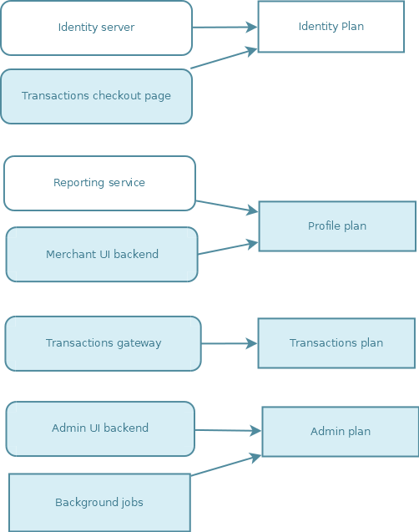

### Main service components:

* Identity server – login page, authentication (including API tokens), account management (by user himself), users management API (for admin)
* Transactions checkout page – main site with redirect page which should be used on merchant's web-store
* Reporting service – API to be used on UI (both admin and merchant) to generate dashboard
* Merchant UI backend – settings and metadata management for merchant view (also host for merchant UI files)
* Transactions gateway – main solution API
* Admin UI backend – merchant's management API (also host for admin UI files)
* Background jobs – set of Azure Functions, mainly to organize some data processing in async mode by queue or by timer.

### List of databases

MS SQL (Azure SQL) databases:

* Merchants DB – all merchants and terminal settings, merchant's metadata
* Identity DB – all users
* Reports DB – aggregated data for dashboard
* Transactions DB – main solution database
* System DB – error log

Azure table storage:

* Requests logs (incoming/outgoing)
* Emails log
* SMSs log

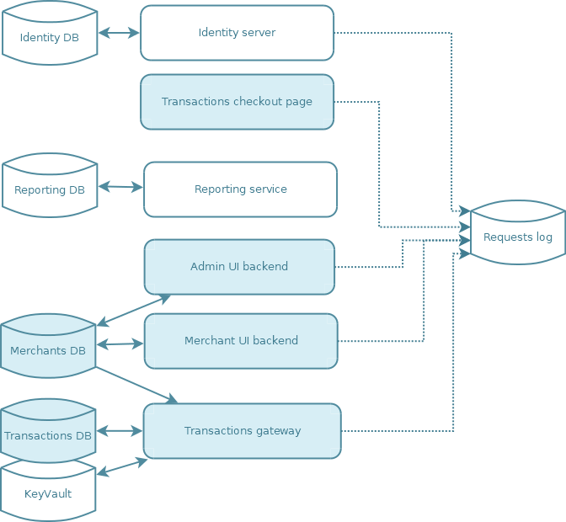

### Services interaction

